Stuff you’ll need to order from AliExpress

(Quantities and specifics are in RED)

E28-2G4M27S SX1280 Wireless module 2.4G 27dBm SPI Wireless ranging positioning LoRa Wireless Transceiver Long range 8000m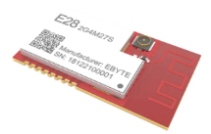

* [E28 2G4M27S SX1280 Wireless module 2.4G 27dBm SPI Wireless ranging positioning LoRa Wireless Transceiver Long range 8000m|Fixed Wireless Terminals| - AliExpress](https://www.aliexpress.com/item/33004335921.html?spm=a2g0s.9042311.0.0.17854c4dX7L4KH)

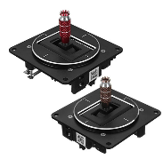

FrSky M10 Gimbals.

* [Frsky m10 high sensitivity hall sensor gimbal for horus x10 x10s rc drone transmitter Sale - Banggood.com](https://usa.banggood.com/FrSky-M10-High-Sensitivity-Hall-Sensor-Gimbal-for-Horus-X10-X10S-RC-Drone-Transmitter-p-1277967.html?gmcCountry=US&currency=USD&cur_warehouse=CN&createTmp=1&ID=228&utm_source=bing_pa&utm_medium=cpc_bgcs&utm_content=haosen&utm_campaign=haosen-pa-usg-toys-rc-pc-0903&ad_id=&msclkid=ac90d7a105e513311eefb7d0b258b7cd)
* [FrSky M10 Gimbal For Horus X10 & X10s (horusrc.com)](https://www.horusrc.com/eng/frsky-m10-gimbal-for-horus-x10-x10s.html)

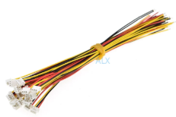

# 20PCS 150MM mini micro JST 1.25 3pin female plug connector with wire 1.25MM 3pin 3p cable (Order 3 and 4 pin connectors)

* 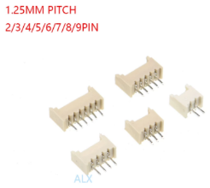[20PCS 150MM mini micro JST 1.25 3pin female plug connector with wire 1.25MM 3pin 3p cable|Connectors| - AliExpress](https://www.aliexpress.com/item/32886112821.html?spm=a2g0s.9042311.0.0.17854c4dX7L4KH)

# 20pcs MICRO JST connector 1.25MM PITCH MALE pin header 3P/4P/8P Straight needle FOR PCB BOARD 1.25 (Order 3,4, and 8P connectors)

* 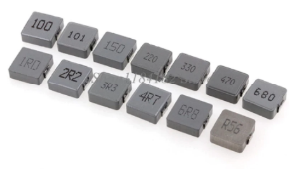[20pcs MICRO JST connector 1.25MM PITCH MALE pin header 2P/3P/4P/5P/6P/7P/8P/9P/10P/11P/12P Straight needle FOR PCB BOARD 1.25|Connectors| - AliExpress](https://www.aliexpress.com/item/32887462907.html?spm=a2g0s.9042311.0.0.17854c4dX7L4KH)

# Integrally Molded 10*10*4 Power Inductor 1040 100UH (Order 100UH Inductors)

* [Integrally Molded 10*10*4 Power Inductor 1040 0.56UH 1UH 2.2UH 3.3UH 4.7UH 6.8UH 10UH 100UH 115UH 22UH 33UH 47UH 68UH 10X10X4|Inductors| - AliExpress](https://www.aliexpress.com/item/4000623206812.html?spm=a2g0s.9042311.0.0.17854c4dX7L4KH)

# M4 Lifting Eye Bolts 304 stainless steel Lifting Ring Screws Eye Bolt (Order M4 Eye Bolts)

* [M3 M4 M5 M6 M8 M10 M12 Lifting Eye Bolts 304 stainless steel Lifting Ring Screws Eye Bolt|Bolts| - AliExpress](https://www.aliexpress.com/item/33010957846.html?spm=a2g0s.9042311.0.0.27424c4dr6YM29)

# 

# 5/10/20/50PCS M3 M4 M5 M6 M8 M10 M12 Zinc Plated Four Claws Nut Speaker T-nut Blind Pronged Insert Tee Nut Furniture Hardware (Order 5 pieces M4 T-Nut)

* [5/10/20/50PCS M3 M4 M5 M6 M8 M10 M12 Zinc Plated Four Claws Nut Speaker T nut Blind Pronged Insert Tee Nut Furniture Hardware|Nuts| - AliExpress](https://www.aliexpress.com/item/33041388035.html?spm=a2g0o.productlist.0.0.27bb1832krlosR&algo_pvid=9571159d-992d-4c6d-a50c-6abd833a874f&algo_expid=9571159d-992d-4c6d-a50c-6abd833a874f-5&btsid=0bb0623916167173231532974ec3f5&ws_ab_test=searchweb0_0,searchweb201602_,searchweb201603_)

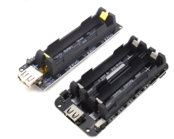

# ESP32 ESP32S For Wemos For Raspberry Pi 18650 Battery Charge Shield Board V3 Micro USB Port Type-A USB 0.5A (Order the 2-cell shield, no charger)

* [ESP32 ESP32S For Wemos For Raspberry Pi 18650 Battery Charge Shield Board V3 Micro USB Port Type A USB 0.5A|Integrated Circuits| - AliExpress](https://www.aliexpress.com/item/4001282850260.html?spm=a2g0s.9042311.0.0.27424c4dr6YM29)

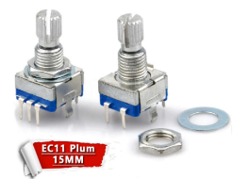

10pcs Plum handle 15mm rotary encoder coding switch / EC11 / digital potentiometer with switch 5 Pin

* [10pcs Plum handle 15mm rotary encoder coding switch / EC11 / digital potentiometer with switch 5 Pin|Potentiometers| - AliExpress](https://www.aliexpress.com/item/32879562482.html?spm=a2g0s.9042311.0.0.27424c4dr6YM29)

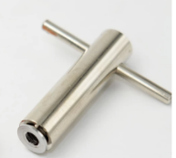

Flysky / Frsky Taranis QX7 X7S X9D Plus Transmitter Parts Tighten Switch Spacer Tool

* [Flysky / Frsky Taranis QX7 X7S X9D Plus Transmitter Parts Tighten Switch Spacer Tool|Parts & Accessories| - AliExpress](https://www.aliexpress.com/item/32995614382.html?spm=a2g0s.9042311.0.0.27424c4dr6YM29)

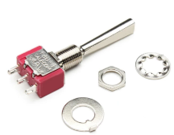

Switch For RadioLink AT9S Futaba JR Frsky X9D Plus QX7 FlySky Walkera WFLY RadioLink switch parts (Be sure to select your desired switches, washers, and nuts)

* [Switch For RadioLink AT9S Futaba JR Frsky X9D Plus QX7 FlySky Walkera WFLY RadioLink switch parts|Parts & Accessories| - AliExpress](https://www.aliexpress.com/item/33017227469.html?spm=a2g0s.9042311.0.0.27424c4dr6YM29)

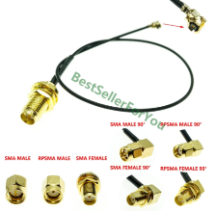

U.FL IPX IPEX UFL to RP-SMA SMA Female Male Antenna WiFi Pigtail 1.13 Cable ufl 1.13mm Pick Your Length (Order SMA Female 90, 15cm length)

- [U.FL IPX IPEX UFL to RP SMA SMA Female Male Antenna WiFi Pigtail 1.13 Cable ufl 1.13mm Pick Your Length|Connectors| - AliExpress](https://www.aliexpress.com/item/4000166668788.html?spm=a2g0s.9042311.0.0.27424c4dr6YM29)

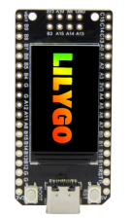

LILYGO® TTGO T-Display-GD32 GD32VF103CBT6 Main Chip ST7789 1.14 Inch IPS 240x135 Resolution Minimalist Development Board

* 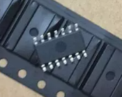[LILYGO® TTGO T Display GD32 GD32VF103CBT6 Main Chip ST7789 1.14 Inch IPS 240x135 Resolution Minimalist Development Board|Circuits| - AliExpress](https://www.aliexpress.com/item/4000598356310.html?spm=a2g0s.9042311.0.0.27424c4dr6YM29)

100PCS LM324DR LM324 SOP-14 3.9MM (Only need 3, but 100 qty. is smallest I could find)

* [100PCS LM324DR LM324 SOP 14 3.9MM|amplifier home|amplifier 3gamplifier bluetooth - AliExpress](https://www.aliexpress.com/item/849324878.html?spm=a2g0s.9042311.0.0.27424c4dr6YM29)
* 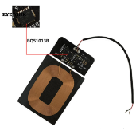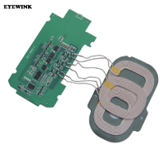

1pcs Wireless Charging Board 10W Fast Qi Standard Charging Universal DIY 3-Coils PCB (Order both transmitter and receiver)

* [1pcs Wireless Charging Board 10W Fast Qi Standard Charging Universal DIY 3 Coils PCB|Integrated Circuits| - AliExpress](https://www.aliexpress.com/item/32980118867.html?spm=a2g0s.9042311.0.0.27424c4dsHPZHS)